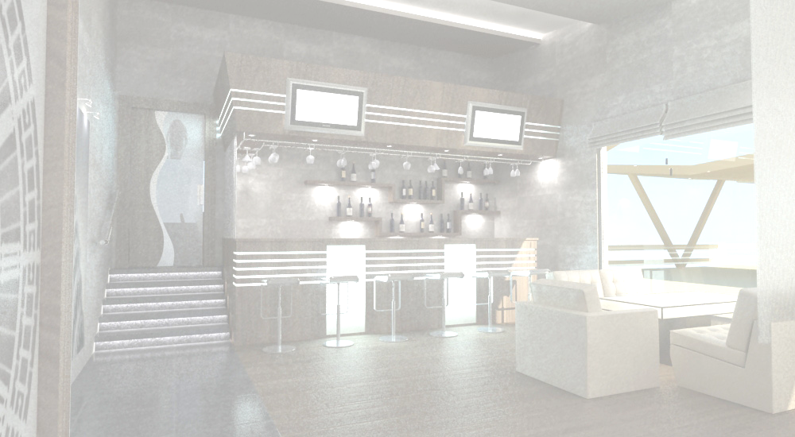
civi kerZi
Cold Apitaizer
mwvanilis asorti: |  |  |  |  | 4.50 | lari
Assort of greens: |  |  |  |  | 4.50 | GEL
fxalis asorti nigvziT: |  |  |  |  | 9.00 | lari
Assort of Georgian Musses: |  |  |  |  | 9.00 | GEL
badrijani nigvziT |  |  |  |  | 5.00 | lari
Eggplant With Walnat |  |  |  |  | 5.00 | GEL
mJavis asorti: ჯონჯოლი,წიწაკა,პომიდორი,კიტრი,კომბოსტო |  |  |  |  | 4.00 | lari
Assort of pickles: plural capers ,Pepper,Picules,cabbage |  |  |  |  | 4.00 | GEL
evropuli yvelis asorti: Sveicaruli, kamamberi, rogfori |  |  |  |  | 25.00 | lari
Assort of Europian Cheese: Sweetland,Kamamber, Rogphor |  |  |  |  | 25.00 | GEL
qarTuli yvelis asorti: sulguni, imeruli, Sebolili |  |  |  |  | 10.00 | lari
Assort of Georgian Cheese: Sulguni, Imeruli, Smoked Sulguni |  |  |  |  | 10.00 | GEL
gudis yveli |  |  |  |  | 8.00 | lari
Cheese "Guda" |  |  |  |  | 8.00 | GEL
naduRi pitniT |  |  |  |  | 4.50 | lari
Cottage Cheese with Mint |  |  |  |  | 4.50 | GEL
naduRi sulgunis firfitaSi |  |  |  |  | 5.50 | lari
Cottage Cheese in “Sulguni” Leaves |  |  |  |  | 5.50 | GEL
"gebJalia" sulgunis ruleti naduRis sousSi |  |  |  |  | 10.00 | lari
"Gebjalia" Suluguni rollet with mint sauce |  |  |  |  | 10.00 | GEL
moxarSuli dedali |  |  |  |  | 45.00 | lari
Boiled Chicken |  |  |  |  | 45.00 | GEL
wiwila: ტყემალში |  |  |  |  | 17.00 | lari
Boiled Young Chicken: In Wild Plum Sauce |  |  |  | 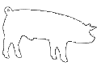 | 17.00 | GEL
Zexvis asorti: |  |  |  |  | 12.00 | lari
Assort of sausages: |  |  |  |  | 12.00 | GEL
goWi Semwvari |  |  |  |  | 25.00 | lari
Saclice Peag |  |  |  |  | 25.00 | GEL
saqonlis ena |  |  |  |  | 6.50 | lari
Beef Tongue |  |  |  |  | 6.50 | GEL
kuWmaWi NnigvziT |  |  |  |  | 10.00 | lari
Veal Pluck With Walnuts |  |  |  |  | 10.00 | GEL
xbos kanWi |  |  |  |  | 13.00 | lari
Boiled Calf Shin |  |  |  |  | 13.00 | GEL
xorcis asorti: saqonlis ena, buJenina, qaTmis ruleti, lori |  |  |  |  | 20.00 | lari
Assort of meat: Boiled Beef Tongue, Pork "bujenina", Chicken rollet, bacon |  |  |  |  | 20.00 | GEL
burvaki |  |  |  |  | 11.00 | lari
Boiled Saclice Peag |  |  |  |  | 11.00 | GEL
lori "raWuli" |  |  |  |  | 20.00 | lari
Bacon "Racha" Style |  |  |  |  | 20.00 | GEL
Roris “ buJenina” |  |  |  |  | 10.00 | lari
Pork "Bujenina" |  |  |  |  | 10.00 | GEL
Tevzis asorti: zuTxi moxarSuli, oraguli, xizilala wiTeli,kreveti |  |  |  |  | 55.00 | lari
Assort of Fish:Boiled Sturgeon,Salmon,Red Caviar,Srimps |  |  |  |  | 55.00 | GEL
loqo nigvzian qinZmarSi |  |  |  |  | 10.00 | lari
Sheat-Fish in Coriander Sauce With Walnuts |  |  |  |  | 10.00 | GEL
loqo qinZmarSi |  |  |  |  | 9.00 | lari
Sheat-Fish in Coriander Sauce |  |  |  |  | 9.00 | GEL
zuTxi moxarSuli |  |  |  |  | 45.00 | lari
Boiled Sturgeon |  |  |  |  | 45.00 | GEL
oraguli nelmarilSi |  |  |  |  | 16.00 | lari
Salmon in slightly Salted |  |  |  |  | 16.00 | GEL
norvegiuli TarTi baJeSi |  |  |  |  | 15.00 | lari
Norwegian Sturgeon in "Baje"( Walnut Sauce ) |  |  |  |  | 15.00 | GEL
xizilala wiTeli |  |  |  |  | 18.00 | lari
Red Caviar |  |  |  |  | 18.00 | GEL
blini oraguliT da wiTeli xizilaliT |  |  |  |  | 22.00 | lari
Blinis With Salmon And Red Caviar |  |  |  |  | 22.00 | GEL
zeTis xili (Savi an mwvane) |  |  |  |  | 4.50 | lari
Olives (Black or Green) |  |  |  |  | 4.50 | GEL
cxare  spicy | vegeterianuli  vegetarian | alkoholuri  Cortains alcohol | 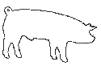  Roris xorci  pork |  18:00 saaTamde  Till 18:00
visac dietis an alergiis gamo surs icodes sakvebis Semadgenloba, gTxovT mimarToT mimtans
For those with special dietary requirements or allergies, please ask our waiter for assistance
momsaxureoba-15%
Service charge-15%

